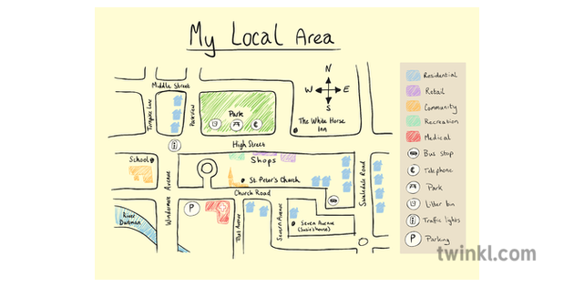

Remote Learning – Spring 1
I’m a year 5/6 child, can you get me out of here?

English:
- Writing a Greek myth;
- Writing for different purposes: to entertain, to inform, to discuss and to persuade;
- Developing the reading skills: retrieve, infer, define, summarise and predict;
- Spelling, Punctuation and Grammar work ;
- Reading – Oxford Reading Buddy and reading comprehension questions linked to our class text;
- Spelling Shed (Uploaded every Monday).

Maths:
Year 5:
- Finding Area and Perimeter;
- Statistics;
- Fractions;
- TT Rockstars and Numbots daily;
- Reasoning & Problem Solving skills.
Year 6:
- Fractions;
- Position and Direction;
- Decimals;
- TT Rockstars and Numbots daily;
- Reasoning & Problem Solving skills.

Science – Earth and Space:
Children will learn to:
- Describe the movement of the Earth, and other planets, relative to the Sun in the Solar system;
- Describe the movement of the Moon relative to the Earth;
- Describe the Sun, Earth and Moon as approximately spherical bodies;
- Use the idea of the Earth’s rotation to explain day and night and the apparent movement of the sun across the sky.

Geography – Fieldwork:
Children will learn to:
- Describe what a bird’s eye view of their local area would look like;
- Explain why their local area exists, what would have brought people to live there in the first place and why people still live there today;
- Use an Ordnance Survey map, including compass point directions, to help someone plan a route between two local points;
- Explain how to get home if they were lost 50 miles from home;
- Plan a trip to a European city.

PSHCE – Safety First:
Children will learn to:
- Explain what ‘responsibility’ means;
- Assess a situation for the level of risk;
- Appreciate that doing something risky may lead to danger;
- Identify people who can help us in an emergency;
- Understand the importance of taking action to reduce the risk of harm;
- Explain how we know which substances around the home contain chemicals;
- Identify safety precautions that can be taken when using roads, railways or water.

