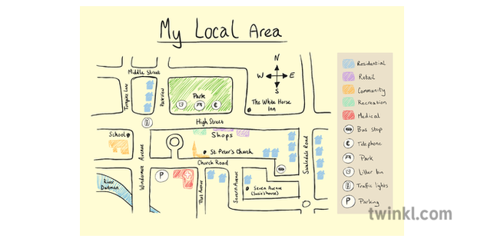

Remote Learning - Spring 2
I’m a year 5/6 child, can you get me out of here?

English:
- Writing for different purposes: to entertain, to inform, to discuss and to persuade;
- Poetry focus – poems from other cultures and traditions.
- Begin Harry Potter unit (modern fiction/fiction from our literary heritage);
- Developing the reading skills: retrieve, infer, define, summarise and predict;
- Spelling, Punctuation and Grammar work ;
- Reading – Oxford Reading Buddy and reading comprehension questions linked to our class text;
- Spelling Shed (Uploaded every Monday).
Maths:
Year 5:
- Fractions;
- Decimals & percentages;
- TT Rockstars and Numbots daily;
- Reasoning & Problem Solving skills.
Year 6:
- Decimals;
- Percentages
- Algebra
- TT Rockstars and Numbots daily;
- Reasoning & Problem Solving skills.

Science – Earth and Space:
Children will learn to:
- Describe the movement of the Earth, and other planets, relative to the Sun in the Solar system;
- Describe the movement of the Moon relative to the Earth;
- Describe the Sun, Earth and Moon as approximately spherical bodies;
- Use the idea of the Earth’s rotation to explain day and night and the apparent movement of the sun across the sky.

Geography – Fieldwork:
Children will learn to:
- Describe what a bird’s eye view of their local area would look like;
- Explain why their local area exists, what would have brought people to live there in the first place and why people still live there today;
- Use an Ordnance Survey map, including compass point directions, to help someone plan a route between two local points;
- Explain how to get home if they were lost 50 miles from home;
- Plan a trip to a European city.

PSHCE – It’s My Body:
Children will learn to:
- Understand that they can choose what happens to their bodies;
- Know where and how to get help if they are worried;
- Understand the importance of sleep, exercise and healthy eating;
- Identify ways in which certain drugs, including tobacco and alcohol can harm their bodies;
- Identify positive aspects about themselves;
- Discuss the choices related to health that they make every day;
- Identify choices that will benefit their health and provide a ‘balanced lifestyle’;
- Identify ways to protect their bodies from ill health.

