Home Learning:
Monday:
- A new spelling assignment is set weekly on Spelling Shed. Children earn points each time they practise their spellings. The children with the highest score on a Friday earns 10 dojos.

- A weekly times table will be set to learn for the week. Children need to know these and the division facts for the Friday when they will be tested in the morning.
PE:
P.E is every Thursday. Children need to come to school wearing their PE kit (black/blue joggers, white t-shirt, red school jumper).
Times Table Rock Stars:
Children are expected to regularly practise their times tables at home and this is an app purchased by school for the children to use. The children who have earned the most virtual coins in a week will receive a certificate and 10 dojos.
Reading:
Children will bring home 1 reading book per week which can be changed on a Friday. Children will also have their log on for Oxford Reading Buddy where they can read other books and answer questions about what they have read. Using this app, we can then monitor which children are reading regularly at home and which level they are reading at.
How you can help:
- remind you child to read for a minimum of 15 minutes every day;
- help your child by testing them on their multiplication tables and other number facts;
- talk to your child about their day at school and what we have been learning about.
Laycock Primary School
Years 5 and 6
Autumn Term 1
The Ancient Greeks
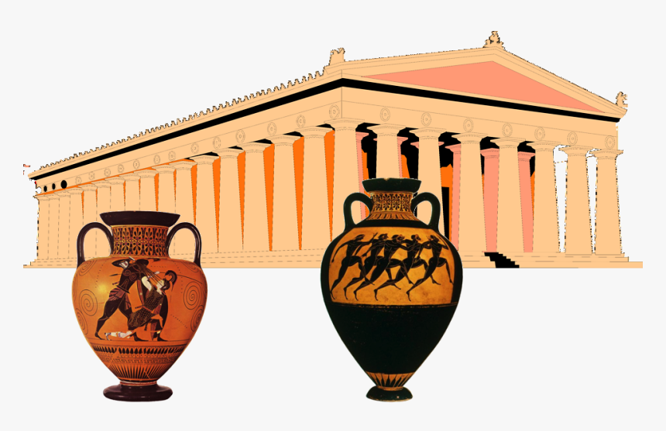

A copy of this leaflet can be found on the school website

English:
- Dragons & Greek Myths – writing for different purposes including: poems, non-fiction, narrative and recount.
- Visual literacy (to be revealed to the children) – writing for different purposes including: character and setting description, persuasive writing, diaries.
- SPAG – focus on using punctuation for effect, word classes and spelling the year 5/6 common words.
- Reading – focus on the 3 skills: Retrieve, Infer and Define.
History:
Greek Myths
Children will learn to:
- know how and why empires grow;
- understand Ancient Greece, Greek life, their achievements and influence on the Western world;
- understand how the political system worked in Ancient Greece;
- find out about Ancient Greek Gods and Goddesses and use this knowledge to plan their own Greek myth;
- compare the life of an 11 year old child from Ancient Greece with their own life;
- explain the significance of the Ancient Greece Olympics.
PSHE:
- New Beginnings

Art and Design:
Drawing
Through the topic of Ancient Greeks children will learn to:
- use a variety of techniques to add effect;
- depict movement and perspective in drawings;
- use a variety of tools and select the most appropriate.
Science:
Living Things & Their Habitats
Children will learn to:
- describe and compare the life cycles of a range of animals, including humans, amphibians, insects and birds;
- describe the life cycles of common plants;
- describe birth, reproduction and death of familiar animals and plants, including humans;
- explore the work of well known naturalists (Jane Goodall and David Attenborough).
R.E:
- This half term we will be learning about different places of worship.
Computing:
Radio Station – Multimedia
Children will learn to:
- record and play their own sounds in recording software;
- plan and record a radio advert;
- listen to and improve their own recordings by re-recording;
- locate and download existing sound files to be imported into recording software.
Maths:
- Place Value
- Addition, subtraction, multiplication and division methods
- Reasoning & Problem Solving skills
- Statistics.
Music:
How can we be like the great composers?
- What are pulse and metre and how are they associated with rhythm?
- How can pitched notes be organised into a melodic phrase?
- What has inspired famous composers?
- Can we compose music based on a theme?
- What musical structures can we include in our composition?
French:
- Listen attentively to spoken language and show understanding by joining in and responding.
P.E:
Outdoor PE
Children will learn to:
- use running, jumping, throwing and catching in isolation and in combination;
- play competitive games (modified where appropriate) and apply basic
principles suitable for attacking and defending.

