LAYCOCK PRIMARY SCHOOL
Years 3 and 4
Autumn 1
A copy of this curriculum leaflet can be found on the school website.

www.laycockprimary.co.uk

Home Learning:
Currently, homework will not be carried between home and school and will instead be accessed online.
Spelling words will be uploaded via Class Dojo on Monday afternoons with a test every Friday morning (Details to follow).

Daily: Oxford Reading Buddy and Times Table Rock Stars
By the end of Year 3: Children should know by heart their 2, 3, 4, 5, 8 and 10 times tables.
By the end of Year 4: Children should know by heart all multiplication facts up to 12 x 12. Year 4 children will undertake a National Multiplication Tables Check.

PE:
PE will be on Thursdays. It is very important that pupils remember their kit- a white polo shirt and black or navy shorts. Long hair must be tied back and earrings removed or covered.

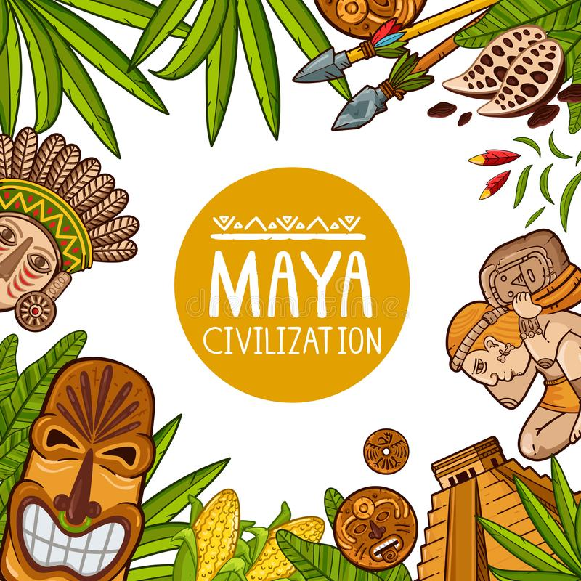

Where and when did The Maya people live?

English
- Writing persuasive letters to help stop deforestation and pollution of the environment
- Writing a story about animals and global warming
- A diary entry from an endangered animal
- Learning to use paragraphs effectively
- Writing a non-fiction report with sub-headings

RE -
- Exploring the main religions and discussing differences in beliefs
- Learning to be tolerant and respectful of each other
Mathematics
- Place value – recognising the value of digits
- Calculation – addition, subtraction,
multiplication and division
- Times tables
- Problem solving and developing reasoning skills

;

English
- ‘The Creakers’ by Tom Fletcher is our class novel
- Recap of basic punctuation and learning to use commas and apostrophes
- Writing scary descriptions and learning to use expanded noun phrases
- Sorting words into their different types (Nouns, verbs, adjectives, verbs and adverbs)
- Daily joined handwriting practise

;

Autumn 1
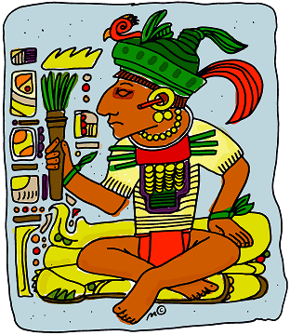

History – The Maya Civilization
- Who were The Maya and how did they live?
- Where is Central America and where is Mexico? What is the climate like?
- What did Maya people look like?
- What did their buildings, houses and temples look like?
- What Maya traditions and rituals were important to them?
- Who invented chocolate?

Science – The Human Body
- Sorting food into the different food groups
- Learning about the importance of a balanced diet
- Naming muscle groups and understanding how muscles work
- Naming the main bones in the skeleton
- Explaining the functions of our organs

Creative Curriculum
- Making Maya masks
- Designing a Maya temple
- Sculpture work using clay
- Performing simple body percussion and copying a simple rhythm
- Music appreciation and learning about different styles of music

Physical Development
- Throwing and catching skills
- Working as part of a team
- The importance of warm-ups and cool downs
- Learning about different muscle groups

Personal, Social and Emotional Health
‘New Beginnings’
- Worries about the new school year
- Goals and targets for this year
- Our strengths and weaknesses
- School rules and routines
- ‘The Colour Monster’ story

Personal, Social and Emotional Development
- New beginnings- settling into their new classroom- exploring feelings.
- Understanding and following class and school rules.
- Talking about our families and friends.
- What we would like to achieve at school?

