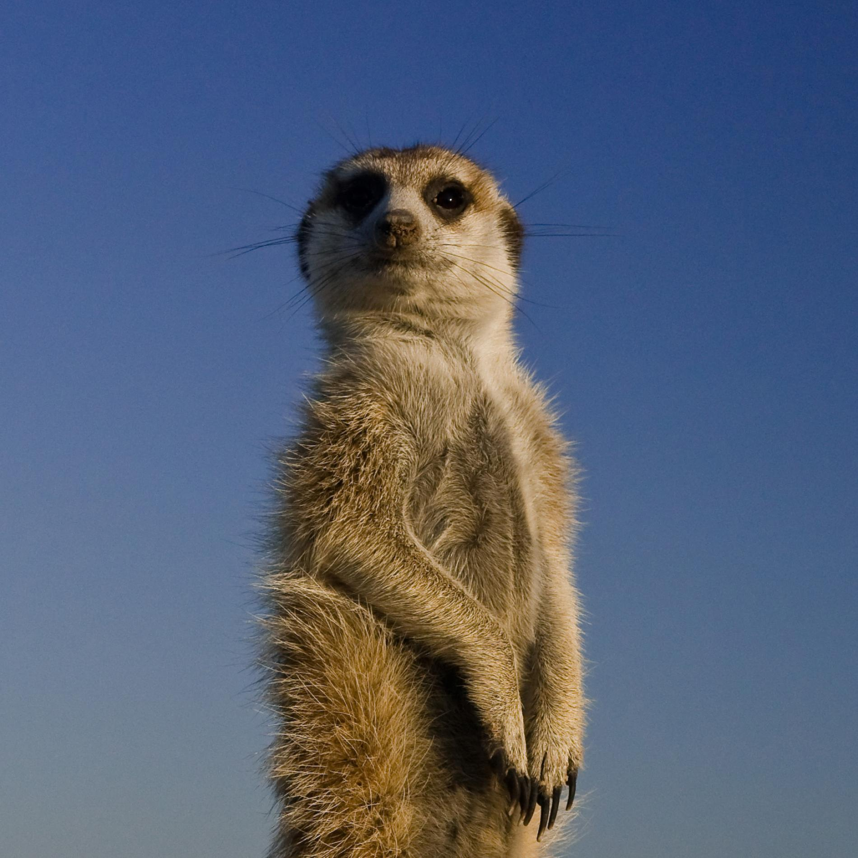
Spring 2
Why can’t a Meerkat live in the North Pole?

English:
- Writing a fable
- Writing a report
- Spelling, Punctuation and Grammar work
- Phonics
- Reading – Oxford Reading Buddy
- Spelling Shed (Uploaded every Monday)

Maths:
- Year 1 - Measurement: length, height, weight and volume
- Year 2 - Geometry: properties of shape
- Year 2 - Number: Fractions
- TT Rockstars and Numbots daily
- Reasoning & Problem Solving skills

Science – Living Things and their Habitats:
Children will learn to:
- Explore and compare differences between things that are living, dead and things that have never been alive
- Identify that most living things live in habitats to which they are suited
- Identify and name a variety of plants and animals in their habitats, including micro-habitats
- Describe how animals obtain their food from plants and other animals

Geography:
Children will learn to:
- Describe seasonal and daily weather patterns in hot and cold areas of the world
- Understand the geographical similarities and differences between Keighley, the Kalahari desert and North Pole
- Identify key physical features of Keighley, Kalahari desert and North Pole
- Use world maps, atlases and globes to identify countries, continents and oceans.

