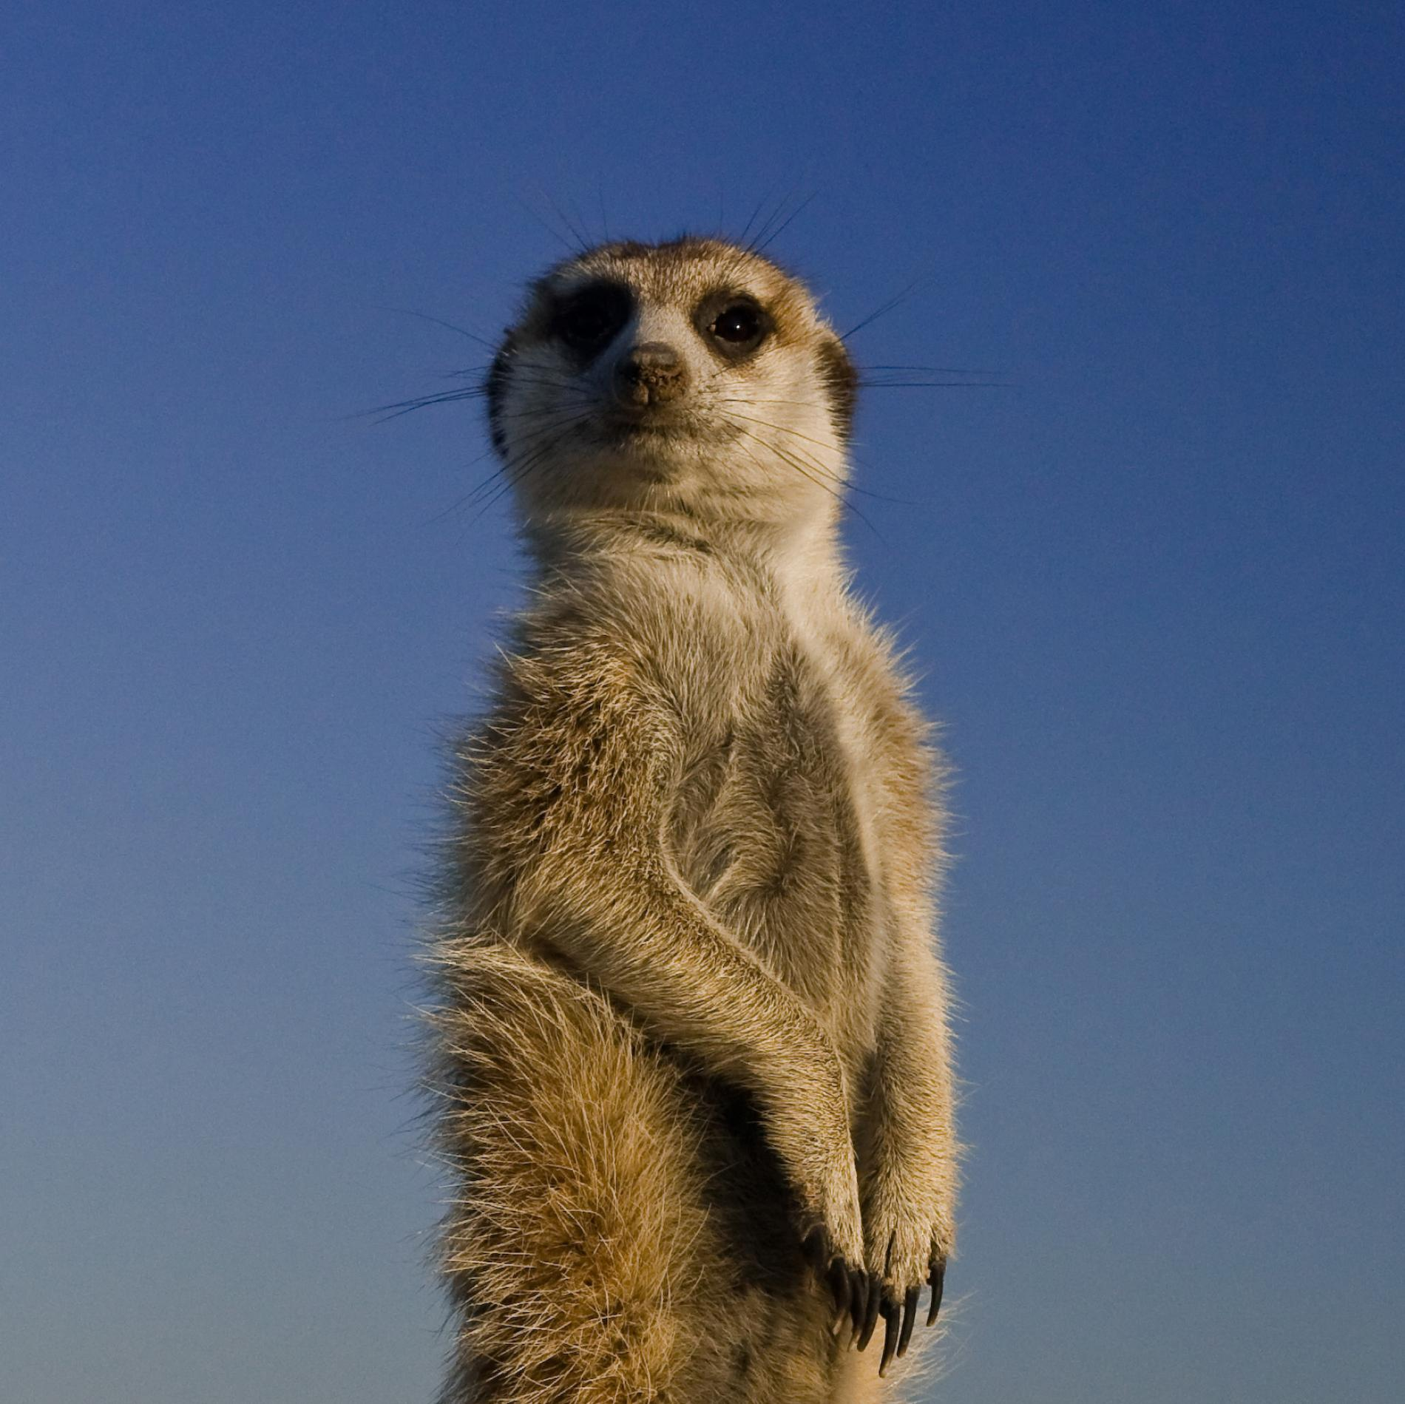
Remote Learning – Spring 1
Why can’t a Meerkat live in the North Pole?

English:
- Writing a recount based on ‘The Dark’ by Lemony Snicket
- Writing a letter based on ‘Meerkat Mail’ by Emily Gravett
- Spelling, Punctuation and Grammar work
- Phonics
- Reading – Oxford Reading Buddy
- Spelling Shed (Uploaded every Monday)

Maths:
- Multiplication and division methods
- Statistics including tally charts and pictograms
- Place value
- Addition and subtraction methods
- TT Rockstars and Numbots daily
- Reasoning & Problem Solving skills

Science – Animals, including humans:
Children will learn to:
- Sort and describe wild and not wild animals
- Explain why animals choose to live in their habitat
- Explain what a carnivore, herbivore and omnivore are
- Explain what we need to do to keep our pets happy
- Investigate the role of a zookeeper

Geography:
Children will learn to:
- Name and locate the world’s seven continents and five oceans
- Understand the geographical similarities and differences between Keighley, the Kalahari desert and North Pole
- Describe seasonal and daily weather patterns in hot and cold areas of the world
- Identify geographical features on the world
- Use world maps, atlases and globes to identify countries, continents and oceans.

