LAYCOCK PRIMARY SCHOOL
Years 1 and 2
Autumn 1
A copy of this curriculum leaflet can be found on the school website.

www.laycockprimary.co.uk

Home Learning:
Currently, homework will not be carried between home and school and will instead be accessed online.
Spelling words will be uploaded via Class Dojo on Monday afternoons with a test every Friday morning (Details to follow).

Daily: Oxford Reading Buddy and Times Table Rock Stars
By the end of Year 2: Children should know by heart their 2, 5 and 10 times tables.

PE:
PE will be on Thursdays. It is very important that pupils remember their kit- a white polo shirt and black or navy shorts. Long hair must be tied back and earrings removed or covered.

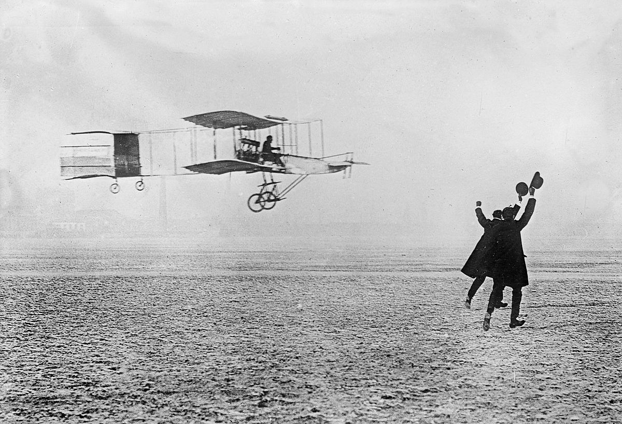

Magnificent Machines
(First Flight and Steam trains)

English
- Writing persuasive letters to help stop deforestation and pollution of the environment
- Writing a story about animals and global warming
- A diary entry from an endangered animal
- Learning to use paragraphs effectively
- Writing a non-fiction report with sub-headings

RE -
- Learning that every person is special and unique
- Reflect on our sense of identity and belonging
Mathematics
- Place value – recognising the value of digits
- Calculation – addition and subtraction,
- Times tables
- Problem solving and developing reasoning skills

;

English
- ‘Matilda’ by Roald Dahl is our class novel
- Writing traditional tales and fantasy stories
- Capital letters, full stops and finger spaces
- Features of speech
- Writing question and exclamation sentences
- Writing in paragraphs
- Daily joined handwriting practise

;

Autumn 1

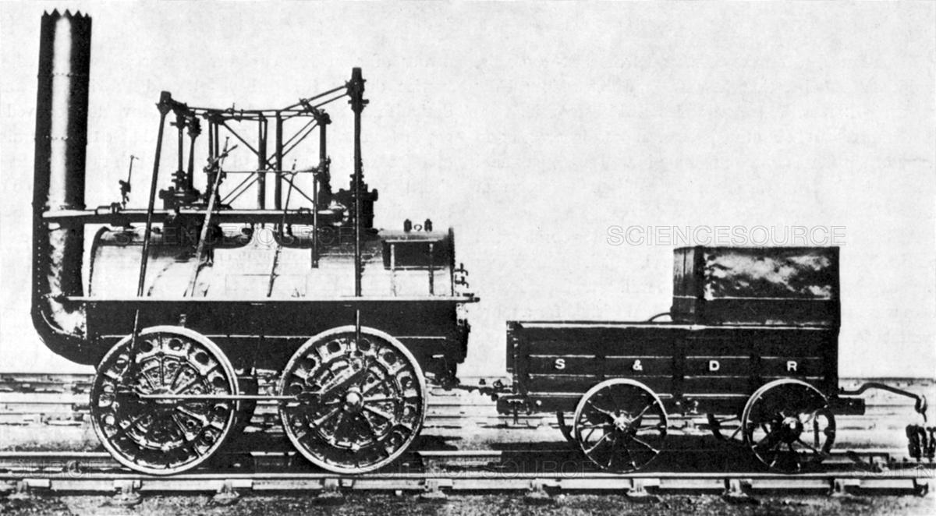

History – Marvellous Machines
- How did people fly before the invention of aeroplanes?
- Who were the Wright Brothers?
- How have aeroplanes changed over time?
- How has transport changed over time?
- Who was George Stephenson and what did he invent?
- How have trains changed people’s lives in the 19th century?
- How has the Keighley Worth Valley railway changed over time?

Science – Materials (Three Little Pigs)
- What is the best material for the three little pigs to use for their house?
- Learning about structures and different building materials
- Learning about the properties of materials.
- Testing different materials to investigate which material would be best suited for building a structure

Creative Curriculum
- Making structures using different materials
- Turning a photograph into a painting
- Designing and making a marvellous machine using different materials
- Playing instruments in time to music
- Music appreciation and learning about different composers

Physical Development
- Throwing and catching skills
- Team games
- Running and jumping skills
- Developing balance, agility and co-ordination

Personal, Social and Emotional Health
‘New Beginnings’
- Worries about the new school year
- Goals and targets for this year
- Our strengths and weaknesses
- School rules and routines
- ‘The Colour Monster’ story

Personal, Social and Emotional Development
- New beginnings- settling into their new classroom- exploring feelings.
- Understanding and following class and school rules.
- Talking about our families and friends.
- What we would like to achieve at school?

