Home Learning:
Monday:
- A new spelling assignment is set weekly on Spelling Shed. Children earn points each time they practise their spellings. The children with the highest score on a Friday earns a prize.
PE:
P.E is every Thursday. Children need to come to school wearing their PE kit (black/blue joggers, white t-shirt, red school jumper).
Times Table Rock Stars & Numbots:
Children are expected to regularly practise their times tables and number facts at home and these are apps purchased by school for the children to use. The children who have earned the most virtual coins in a week will receive a certificate and 10 dojos.
Reading:
Children will bring home a reading book with their yellow reading diary. Please sign in their reading diary every time that your child reads at home. When your child has read 25 times at home and had their book signed, they will get a non-uniform voucher to use whenever they want!
How you can help:
- remind you child to read for a minimum of 15 minutes every day;
- help your child by testing them on their multiplication tables and other number facts;
- talk to your child about their day at school and what we have been learning about.
Laycock Primary School
Years 5 and 6
Summer 2 - 2022
Rainforests
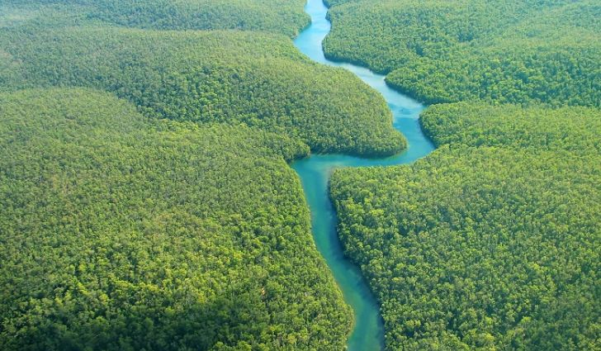

A copy of this leaflet can be found on the school website

English:
- The Journey by Francesca Sanna– writing for different purposes including: writing to entertain (including poetry), writing to inform, writing to persuade and writing to discuss.
- SPAG – to consolidate use of description to enable children to express themselves in interesting ways.
- Reading – using all Reading Gem skills.
Maths:
Year 5 children will learn:
- Position & direction;
- Converting units;
- Volume.
Year 6 children will learn:
- Consolidation & themed projects.
Geography:
Rainforests
Children will learn to:
- identify and locate the world’s rainforests explaining why they are found in these locations;
- compare an area in the Amazon rainforest with our local area;
- describe and understand key aspects of physical geography, including: climate zones, biomes and vegetation belts, mountains and the water cycle;
- explain why water is such a valuable commodity;
- use maps, globes, atlases and digital mapping to locate rainforests and describe features;
- locate and name the main countries in South America.

PSHCE:
Growing Up
Children will learn to:
- explain how to look after their bodies during puberty;
- name some ways to cope with new or difficult emotions;
- describe some of the ways in which the media fuels the notion of a perfect body;
- describe the different types of loving relationships that exist;
- use a range of key vocabulary when discussing differences in sex, gender identity and sexual orientation.
Design Technology:
Textiles
Children will learn to:
- carry out research about soft toys;
- consider safety aspects when designing a soft toy for a young child;
- use sketches and annotated drawings to indicate the design of a soft toy;
- select appropriate materials and tools;
- apply a range of aesthetically pleasing finishing techniques;
- evaluate the overall design and effectiveness against a design criteria.
Science:
We are Scientists/Working Scientifically
Children will learn to:
- describe Margaret Hamilton’s work on programming the onboard computer for the Apollo 11 spacecraft;
- explain whether evidence supports or refutes ideas;
- explain Neil deGrasse Tyson’s ideas about Pluto;
- list the planets in our Solar System.

R.E:
- This half term we will be learning: What do Christians believe about the old and new covenants?
Computing:
Computer systems & networks – Sharing Information
Children will learn to:
- explain the importance of internet addresses;
- recognise how data is transferred across the internet;
- evaluate different ways of working together online;
- recognise how we communicate using technology;
- describe how to protect ourselves when sharing information.
Music:
How can we show our class has the X-factor?
Children will learn to:
- make decisions about which song to sing;
- sing in two parts and harmonies;
- select instruments to accompany the song;
- consider what else makes a good performance;
- evaluate their performances.
French:
Let’s go shopping
Children will learn to:
- describe the shopping experience in France;
- use the nuances of colour when describing clothes;
- use prepositional phrases;
- use key phrases for asking questions when going shopping;
- write money amounts in French.

