Home Learning:
Monday:
- A new spelling assignment is set weekly on Spelling Shed. Children earn points each time they practise their spellings. The children with the highest score on a Friday earns a prize.
PE:
P.E is every Thursday. Children need to come to school wearing their PE kit (black/blue joggers, white t-shirt, red school jumper).
Times Table Rock Stars & Numbots:
Children are expected to regularly practise their times tables and number facts at home and these are apps purchased by school for the children to use. The children who have earned the most virtual coins in a week will receive a certificate and 10 dojos.
Reading:
Children will bring home a reading book with their yellow reading diary. Please sign in their reading diary every time that your child reads at home. When your child has read 25 times at home and had their book signed, they will get a non-uniform voucher to use whenever they want!
How you can help:
- remind you child to read for a minimum of 15 minutes every day;
- help your child by testing them on their multiplication tables and other number facts;
- talk to your child about their day at school and what we have been learning about.
Laycock Primary School
Years 5 and 6
Summer 1 - 2022
Rainforests
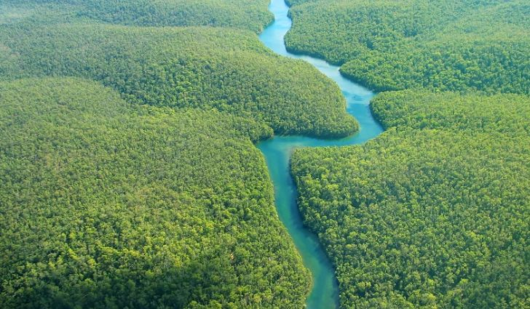

A copy of this leaflet can be found on the school website

English:
- Boy 87 by Eli Fountain – writing for different purposes including: writing to entertain (including poetry), writing to inform, writing to persuade and writing to discuss.
- SPAG – use dialogue; use hyphens to avoid ambiguity; use passive voice; use a wide range of adjectives and adjectival phrases, adverbs, adverbials and prepositional phrases to add description and elaboration to writing.
- Reading – using all Reading Gem skills.
Maths:
Year 5 children will learn:
- Decimals;
- Properties of shape.
Year 6 children will learn:
- Statistics;
- Properties of shape.
Geography:
Rainforests
Children will learn to:
- identify and locate the world’s rainforests explaining why they are found in these locations;
- compare an area in the Amazon rainforest with our local area;
- describe and understand key aspects of physical geography, including: climate zones, biomes and vegetation belts, mountains and the water cycle;
- explain why water is such a valuable commodity;
- use maps, globes, atlases and digital mapping to locate rainforests and describe features;
- locate and name the main countries in South America.

PSHCE:
Growing Up
Children will learn to:
- explain how to look after their bodies during puberty;
- name some ways to cope with new or difficult emotions;
- describe some of the ways in which the media fuels the notion of a perfect body;
- describe the different types of loving relationships that exist;
- use a range of key vocabulary when discussing differences in sex, gender identity and sexual orientation.
Art & Design:
Collage
Children will learn to:
- sketch their original ideas, noting the different techniques they will use;
- predict the effect that different printing techniques will have;
- express mood and emotion through their collage;
- develop their original ideas further through sketching and digital forms of media;
- use key vocabulary to demonstrate knowledge and understanding- texture, shape, form, pattern, structure.
Science:
Animals including humans
Children will learn to:
- order the stages of human development;
- demonstrate understanding of how babies grow in height;
- explain the main changes that take place in old age;
- name the six stages of human development;
- give reasons why changes happen during puberty.

R.E:
- This half term we will be learning: What do Christians believe about the old and new covenants?
Computing:
Scratch – Animated stories
Children will learn to:
- animate characters with movement and speech in a story scene;
- create a sequence of story scenes with added audio;
- structure and sequence the animation of characters in each scene;
- use the repeat command to create animation effect;
- make a character visible or invisible at the correct times.
Music:
Where can we get inspiration for our music?
Children will learn to:
- recognise what might inspire them to write music and what inspired the great composers;
- use music to describe a place, mood or person;
- describe how a change in tempo affects the ‘feel’ of music;
- describe how chords, melodies and bass lines all fit together;
- compose their own piece of music.
French:
That’s Tasty
Children will learn to:
- take part in a role play using food vocabulary;
- write words and phrases from memory;
- use the correct masculine or feminine form for ‘some’.

