Home Learning:
Monday:
- A new spelling assignment is set weekly on Spelling Shed. Children earn points each time they practise their spellings. The children with the highest score on a Friday earns a prize.
PE:
P.E is every Thursday. Children need to come to school wearing their PE kit (black/blue joggers, white t-shirt, red school jumper).
Times Table Rock Stars & Numbots:
Children are expected to regularly practise their times tables and number facts at home and these are apps purchased by school for the children to use. The children who have earned the most virtual coins in a week will receive a certificate and 10 dojos.
Reading:
Children will bring home a reading book with their yellow reading diary. Please sign in their reading diary every time that your child reads at home. When your child has read 25 times at home and had their book signed, they will get a non-uniform voucher to use whenever they want!
How you can help:
- remind you child to read for a minimum of 15 minutes every day;
- help your child by testing them on their multiplication tables and other number facts;
- talk to your child about their day at school and what we have been learning about.
Laycock Primary School
Years 5 and 6
Spring 2 - 2022
Stone Age to Iron Age
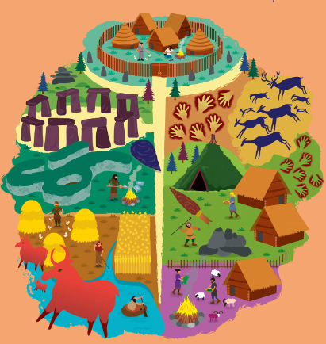

A copy of this leaflet can be found on the school website

English:
- The Hobbit by JRR Tolkein – writing for different purposes including: writing to entertain (including poetry), writing to inform, writing to persuade and writing to discuss.
- SPAG – to use bullet points and punctuate correctly; to use colons and semi-colons in punctuating bullet points; use apostrophes correctly; use modal verbs to indicate possibility.
- Reading – Reading Gem skills: Retrieve, Infer, Define, Summarise, Compare.
Maths:
Year 5 children will learn:
- Fractions;
- Decimals & percentages.
Year 6 children will learn:
- Converting units;
- Perimeter, area & volume;
- Ratio.
History:
Stone Age to Iron Age
Children will learn to:
- understand what is meant by prehistory and know where it fits in with other History topics;
- describe the threats to early mankind;
- understand the importance of farming during prehistory and the change from hunter gatherers to farming;
- describe how homes changed from Stone Age to Iron Age and what this tells them about how Britain was changing;
- describe how bronze replaced stone in the Bronze Age and the implications of this;
- discuss the impact of iron on people during this period and why it took so long for iron to reach Britain;
- describe the limitations of the evidence from this period.

PSHCE:
Think positive
Children will learn to:
- describe how their thoughts, feelings and behaviours influence each other;
- explain the range and intensity of their feelings to others;
- name some strategies to deal with unhelpful thoughts;
- know how to make an informed choice;
- appreciate how making good choices can make us happy;
- understand how mindfulness techniques can be used in their everyday lives;
- describe the difference between a growth mindset and a fixed mindset;
- identify strategies for facing a challenge.
Design Technology:
Sculpture
Children will learn to:
- conduct research into why shelters are used and which materials they are made from;
- design a shelter using detailed, annotated diagrams and sketches;
- select tools appropriate to the task and use them safely;
- accurately and securely attach and assemble the shelter;
- critically evaluate the effectiveness of the design when considering its purpose.
Science:
Light
Children will learn to:
- explain how light travels to enable us to see;
- understand that all objects reflect light;
- identify the angles of incidence and reflection;
- understand refraction as light bending or changing direction;
- explain how a prism allows us to see the visible spectrum;
- understand that colours are a result of light reflecting off an object;
- explain Isaac Newton’s experiments about light and colour;
- understand that shadows are the same shape as the object that casts them.
R.E:
- This half term we will be learning: How does growing up bring responsibilities and commitments?
Computing:
Multimedia – Vector drawing
Children will learn to:
- identify that drawing tools can be used to produce different outcomes;
- create a vector drawing by combining shapes;
- recognise that vector drawings consist of layers;
- group objects to make them easier to work with.
Music:
Are words enough?
Children will learn to:
- describe how the melody reflects the lyrics in a song;
- name some of the great song writers from different periods in history;
- describe how songs are structured;
- write their own lyrics and sing an ostinato for their own piece of music;
- use notation to help them compose.
French:
Time and place
Children will learn to:
- say the days of the week, months of the year and the seasons;
- say which activities they enjoy doing;
- say some school subjects and state which they dislike.

