Home Learning:
Monday:
- A new spelling assignment is set weekly on Spelling Shed. Children earn points each time they practise their spellings. The children with the highest score on a Friday earns a prize.
PE:
P.E is every Thursday. Children need to come to school wearing their PE kit (black/blue joggers, white t-shirt, red school jumper).
Times Table Rock Stars & Numbots:
Children are expected to regularly practise their times tables and number facts at home and these are apps purchased by school for the children to use. The children who have earned the most virtual coins in a week will receive a certificate and 10 dojos.
Reading:
Children will bring home a reading book with their yellow reading diary. Please sign in their reading diary every time that your child reads at home. When your child has read and had their book signed, they get a raffle ticket for our reading raffle which takes place on a Friday morning.
How you can help:
- remind you child to read for a minimum of 15 minutes every day;
- help your child by testing them on their multiplication tables and other number facts;
- talk to your child about their day at school and what we have been learning about.
Laycock Primary School
Years 5 and 6
Spring 1 - 2022
Stone Age to Iron Age
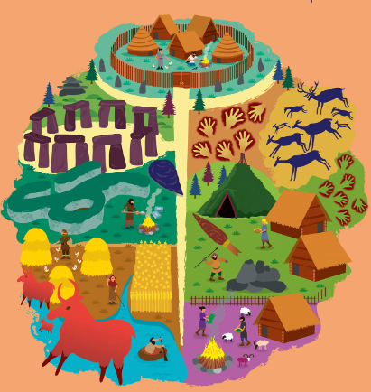

A copy of this leaflet can be found on the school website

English:
- The Wild Way Home by Sophie Kirtley – writing for different purposes including: writing to entertain (including poetry), writing to inform, writing to persuade and writing to discuss.
- SPAG – use brackets, dashes or commas to show parenthesis; recognise and use direct and indirect speech; distinguish between formal and informal language.
- Reading – Reading Gem skills: Retrieve, Infer, Define, Explore, Relate.
Maths:
Year 5 children will learn:
- Multiplication & Division;
- Fractions.
Year 6 children will learn:
- Decimals;
- Percentages;
- Algebra.
History:
Stone Age to Iron Age
Children will learn to:
- understand what is meant by prehistory and know where it fits in with other History topics;
- describe the threats to early mankind;
- understand the importance of farming during prehistory and the change from hunter gatherers to farming;
- describe how homes changed from Stone Age to Iron Age and what this tells them about how Britain was changing;
- describe how bronze replaced stone in the Bronze Age and the implications of this;
- discuss the impact of iron on people during this period and why it took so long for iron to reach Britain;
- describe the limitations of the evidence from this period.

PSHCE:
Aiming High
Children will learn to:
- identify skills and attributes that are useful in many roles;
- identify their preferred learning style;
- identify potential barriers to success;
- identify opportunities that might be available to them in the future;
- identify and challenge stereotypes;
- explain different routes into further education and work;
- understand the different roles within a team;
- discuss challenges many people face and how to overcome them.
Art & Design:
Printing
Children will learn to:
- sketch, edit and adapt their print designs through sketches;
- experiment with different techniques such as depth of inprint and predicting the result;
- use key vocabulary to discuss their work and the work of others;
- create different prints using a range of techniques and where appropriate tools.
Science:
Evolution
Children will learn to:
- develop an understanding of the development of evolutionary ideas and theories over time;
- explain how human evolution has occurred and compare modern humans with those of the same genus and family;
- understand that adaptation and evolution is not a uniform process for all living things;
- give examples of selective and crossbreeding.

R.E:
- This half term we will be learning: How does growing up bring responsibilities and commitments?
Computing:
Scratch: Developing games
Children will learn to:
- move and edit blocks as part of an algorithm;
- program an algorithm as a sequence of game instructions with actions and consequences;
- add additional effects and features, such as sound or point scoring, to enhance the appeal of a game.
Music:
What’s that drumming sound?
Children will learn to:
- describe cultures with a musical tradition of drumming;
- follow the rhythm of speech with body percussion;
- play a variety of cyclic patterns on drums;
- learn drumming rhythms and patterns from other cultures;
- improvise rhythms using percussion instruments;
- develop and showcase a group drumming performance.
French:
Time and place
Children will learn to:
- talk about the weather;
- talk about body parts;
- use colour to describe objects;
- recognise and talk about different modes of transport;
- tell the time in French (hour, quarter past/to, half past).

