Curriculum leaflet for Reception Summer 2021
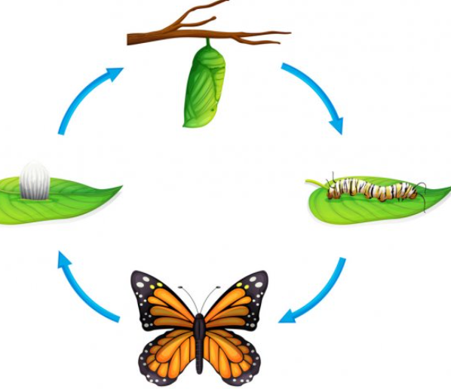

Phonics
- Phase 4/5 coverage
- Personalised phase 3 coverage for those that need it
- Tricky words
- Segmenting for spelling
- Using robot arms to decode independently.
English
- Using segmenting for spelling
- Applying our phonics knowledge
- Letter formation- ensuring our letters are formed properly
- Sitting our writing on the line
- Finger spaces
- Capital letters and full stops
- Using adjectives in sentences
- Using a range of fiction and non-fiction books to inspire reading and writing beginning with Handa’s surprise and Africa!
Maths
- Representing and making amounts up to 20 and beyond
- Doubling amounts
- Learning doubles facts
- Halving amounts
- Naming and describing 2d and 3d shapes
- Using and making tangrams
- O’clock and half past the hour
- Estimating amounts
- Number track games
- Counting on from a certain number

- Creative , People, cultures and communities and Understanding of the world

- The life cycle of a butterfly- we will have caterpillars in school to observe and look after.

- Learning about different countries/ways of life- Africa focus.

- Comparing Keighley with other places in the world.

- Testing materials to make boats for the sea

- Learning about sea creatures and making comparisons

- Growing our own plants- What do plants need to thrive?

- Places of worship- know about church and the mosque

